

Southern Luzon State University
COLLEGE OF ENGINEERING
Computer Engineering Department
Lucban, Quezon

CPE22L: Digital Signal Processing Laboratory

Activity # 9: Digital Processing of Continuous-Time Signals

PADUADA, Dave Jhared G.

DOP: Dec 3, 2025
DOS: Dec 10, 2025

RATING

Engr. Ralph Monsour Delima
INSTRUCTOR

- Objectives
  - To learn how to generate Continuous Time Signals using MATLAB.
  - To understand the significance of CTS in digital signal processing.
  - To identify the difference between digital and continuous time signals.
- Introductory Information

Digital signal processing algorithms are often used to process continuous-time signals. To this end, it is necessary to convert a continuous-time signal into an equivalent discrete-time signal, apply the necessary digital signal processing algorithm to it, and then convert back the processed discrete-time signal into an equivalent continuous-time signal. In the ideal case, the conversion of a continuous-time signal into a discrete-time form is implemented by periodic sampling and, to prevent aliasing, an analog anti-aliasing filter is often placed before sampling to band limit the continuous-time signal. The conversion of a discrete-time signal into a continuous-time signal requires an analog reconstruction filter. In this activity you will investigate the effect of sampling in the time domain and the frequency domain, respectively, and the design of the analog filters. In addition, you will learn the basics of analog-to-digital and digital-to-analog conversions.

The Sampling Process in the Time Domain
The purpose of this section is to study the relation in the time domain between a continuous time signal xa(t) and the discrete-time signal x[n] generated by a periodic sampling of xa(t).

- Data & Procedures

% Program P9_1  % Illustration of the Sampling Process in the Time Domain  clf;  t = 0:0.0005:1;  f = 13; % frequency  xa = cos(2*pi*f*t);  subplot(2,1,1)  plot(t,xa);grid  xlabel('Time, msec');ylabel('Amplitude');  title('Continuous-time signal x_{a}(t)');  axis([0 1 -1.2 1.2])  subplot(2,1,2);  T = 0.1; % sampling period  n = 0:T:1;  xs = cos(2*pi*f*n);  k = 0:length(n)-1;  stem(k,xs); grid  xlabel('Time index n');ylabel('Amplitude');  title('Discrete-time signal x[n]');  axis([0 (length(n)-1) -1.2 1.2]) | % Program P9_2  % Illustration of Aliasing Effect in the Time Domain  % Program adapted from [Kra94] with permission from  % The Mathworks, Inc., Natick, MA.  clf;  T = 0.1;f = 13;  n = (0:T:1)';  xs = cos(2*pi*f*n);  t = linspace(-0.5,1.5,500)';  ya = sinc((1/T)*t(:,ones(size(n))) - (1/T)*n(:,ones(size(t)))')*xs;  plot(n,xs,'o',t,ya);grid;  xlabel('Time, msec');ylabel('Amplitude');  title('Reconstructed continuous-time signal y_{a}(t)');  axis([0 1 -1.2 1.2]);
% Program P9_3  % Illustration of the Aliasing Effect in the Frequency Domain  clf;  t = 0:0.005:10;  xa = 2*t.*exp(-t);  subplot(2,2,1)  plot(t,xa);grid  xlabel('Time, msec');ylabel('Amplitude');  title('Continuous-time signal x_{a}(t)');  subplot(2,2,2)  wa = 0:10/511:10;  ha = freqs(2,[1 2 1],wa);  plot(wa/(2*pi),abs(ha));grid;  xlabel('Frequency, kHz');ylabel('Amplitude');  title('|X_{a}(j\Omega)|');  axis([0 5/pi 0 2]);  subplot(2,2,3)  T = 1;  n = 0:T:10;  xs = 2*n.*exp(-n);  k = 0:length(n)-1;  stem(k,xs);grid;  xlabel('Time index n');ylabel('Amplitude');  title('Discrete-time signal x[n]');  subplot(2,2,4)  wd = 0:pi/255:pi;  hd = freqz(xs,1,wd);  plot(wd/(T*pi), T*abs(hd));grid;  xlabel('Frequency, kHz');ylabel('Amplitude');  title('|X(e^{j\omega})|');  axis([0 1/T 0 2]) | % Program P9_4  % Determines the binary equivalent of a decimal number in sign-magnitude form  d = input('Type in the decimal fraction = ');  b = input('Type in the desired wordlength = ');  d1 = abs(d);  beq = [zeros(1,b)];  for k = 1:b  int = fix(2*d1);  beq(k) = int;  d1 = 2*d1 - int;  end  if sign(d) == -1;  bin = [1 beq];  else  bin = [0 beq];  end  disp('The binary equivalent is');  disp(bin)
% Program P9_5  % Determines the decimal equivalent of a binary number in sign-magnitude form  bin = input('Type in the binary fraction = ');  b = length(bin) - 1; d = 0;  for k = 1:b  d = d + bin(k+1)*2^(-k);  end  if sign(bin(1)) == 0;  dec = d;  else  dec = - d;  end  disp('The decimal equivalent is');  disp(dec); | % Program P9_6  % Determines the ones’-complement equivalent of a binary number in sign-magnitude form  bin = input('Type in the binary number = ');  if sign(bin(1)) == 0;  onescomp = bin;  else  bin(1) = 0; onescomp = ~bin;  end  disp('Ones-complement equivalent is');  disp(onescomp);  % Program P9_7  % Determines the two’s-complement equivalent of a negative binary fraction in ones’-complement form  b = input('Type in the binary fraction = ');  F = length(b);  twoscomp = ones(1,F);  c = 1;  for k = F:-1:2  if b(k) & c == 1;  twoscomp(k) = 0; c = 1;  else  twoscomp(k) = b(k) | c; c = 0;  end  end  disp('Twos-complement equivalent is = ');  disp(twoscomp)

- Data and Results
Q9.1 Run Program P9_1 to generate both the continuous-time signal and its sampled version, and display them. | 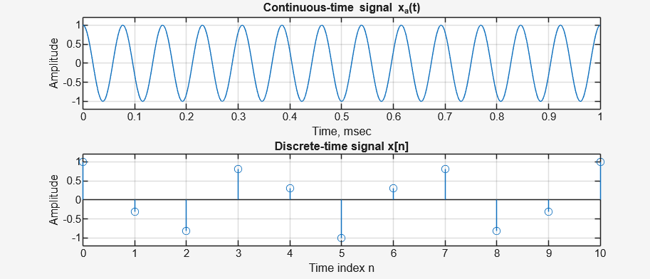
Q9.2 What is the frequency in Hz of the sinusoidal signal? What is the sampling period in seconds? | According to the code in Program P9_1, the frequency of the sinusoidal signal is 13 Hz, as defined by the variable f = 13. The sampling period is 0.1 seconds, as determined by the variable T = 0.1. This corresponds to a sampling frequency (fs​=1/T) of 10 Hz.
Q9.3 Explain the effects of the two axis commands. | The axis command in MATLAB is used to explicitly define the limits of the horizontal (x) and vertical (y) axes for the plot. In the first subplot, axis([0 1 -1.2 1.2]) sets the time axis to display from 0 to 1 second and the amplitude axis from -1.2 to 1.2, ensuring the full continuous wave is visible. In the second subplot, axis([0 (length(n)-1) -1.2 1.2]) sets the x-axis to scale according to the number of discrete samples (indices 0 to 10) while maintaining the same amplitude limits to allow for easy visual comparison between the continuous and discrete signals.
Q9.4 Run Program P9_1 for two other values of the sampling period with one lower and one higher than that listed in Program P9 1. Comment on your results. | Running the program with a lower sampling period (e.g., T<0.1) results in samples that are closer together, creating a discrete signal that more closely resembles the shape of the continuous sine wave because the sampling rate increases (reducing aliasing risk). Conversely, using a higher sampling period (e.g., T>0.1) makes the samples sparser. Because the original sampling rate of 10 Hz (T=0.1) is already below the Nyquist rate for a 13 Hz signal (2×13=26 Hz), the signal is already aliased. Changing T further alters the aliasing relationship, potentially changing the apparent frequency of the discrete signal depending on the new sampling rate f_{s}​.
Q9.5 Repeat Program P9 1 by changing the frequency of the sinusoidal signal to 3 Hz and 7 Hz, respectively. Is there any difference between the corresponding equivalent discrete-time signals and the one generated in Question Q9.1? If not, why not? | When the frequency is changed to 3 Hz and 7 Hz respectively, there is no difference between these corresponding discrete-time signals and the one generated in Question Q9.1 (where f=13 Hz). This is because of aliasing. With a sampling period of T=0.1 s, the sampling frequency is f_{s}​=10 Hz. In digital signal processing, frequencies f that satisfy f=f₀​+k⋅f_{s​} (or f=∣k⋅f_{s}​−f0​∣) appear identical. Here, 13 Hz aliases to 3 Hz (13−10=3), and 7 Hz also aliases to 3 Hz (∣7−10∣=3). Therefore, 3 Hz, 7 Hz, and 13 Hz are all indistinguishable ("aliases" of each other) when sampled at 10 Hz.
Q9.6 Run Program P9_2 to generate both the discrete-time signal x[n] and its continuous time equivalent ya(t), and display them. | 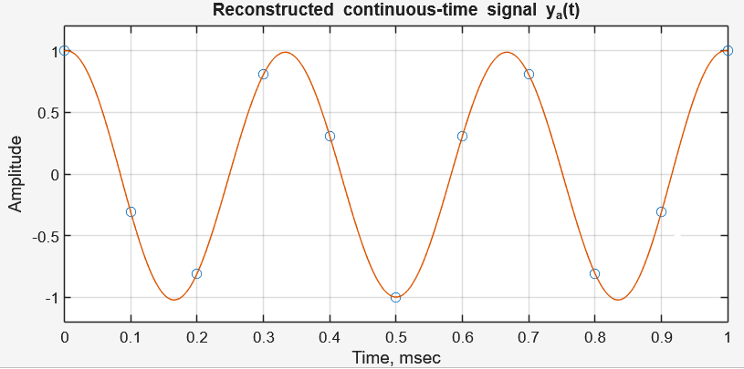
Q9.7 What is the range of t and the value of the time increment in Program P9_2? What is the range of t in the plot? Change the range of t so as to display the full range ya(t) being computed in the above program and run Program P9 2 again. Comment on the plot generated after this change. | In Program P9_2, the time vector t is defined by the command t = linspace(-0.5,1.5,500)';, which sets the computational range of t from -0.5 to 1.5. Since 500 points are generated across this span of 2 units, the time increment is approximately 0.004 seconds (calculated as 2/499). However, the plot command axis([0 1 -1.2 1.2]) restricts the visual display to the range 0 to 1. If the axis range is modified to display the full computed range (-0.5 to 1.5), the plot would reveal the "tails" of the reconstructed signal ya​(t) outside the sampling interval. In these regions (t<0 and t>1), the reconstructed signal would not maintain a perfect constant amplitude; instead, it would ripple and decay toward zero. This occurs because the reconstruction formula uses a finite number of samples (from n=0 to 1), and without infinite samples extending in both directions, the sinc interpolation cannot sustain the sinusoidal oscillation indefinitely.
Q9.8 Restore the original display range and repeat Program P9_2 by changing the frequency of the sinusoidal signal to 3 Hz and 7 Hz, respectively. Is there any difference between the corresponding equivalent discrete-time signals and the one generated in Question Q9.6? If not, why not? | When the frequency is changed to 3 Hz and 7 Hz, there is no difference between the resulting discrete-time signals and the original one generated with 13 Hz in Question Q9.6. This phenomenon is caused by aliasing. With the sampling period set to T=0.1 seconds, the sampling frequency is fs​=10 Hz. In digital signal processing, any frequency f will appear indistinguishable from frequencies determined by ∣f−k⋅fs​∣. Consequently, the original 13 Hz signal aliases to 3 Hz (13−10), and the 7 Hz signal also aliases to 3 Hz (∣7−10∣). Since 3 Hz, 7 Hz, and 13 Hz all map to the same apparent frequency of 3 Hz under this sampling rate, their discrete sample values x[n] are mathematically identical.
Q9.9 What is the continuous-time function xa(t) in Program P9 3? | The continuous-time function xa​(t) in Program P9_3 is defined in the code as xa = 2*t.*exp(-t). In mathematical notation, this is:  xa​(t)=2te^−t for t≥0  This signal represents the impulse response of a critically damped second-order system.
Q9.10 Run Program P9_3 to generate and display both the discrete-time signal and its continuous-time equivalent, and their respective Fourier transforms. Is there any visible effect of aliasing? | 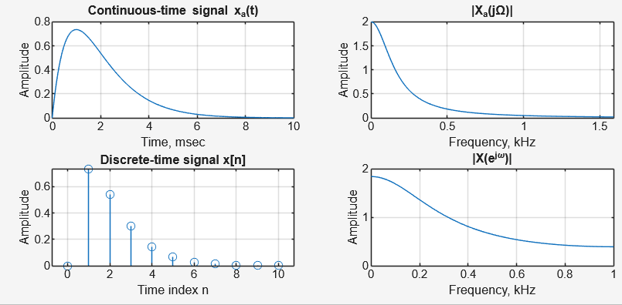  Based on the provided image (which corresponds to T=1), we compare the continuous-time spectrum ∣Xa​(jΩ)∣ (top right) with the discrete-time spectrum ∣X(ejω)∣ (bottom right). The continuous spectrum decays smoothly as frequency increases. The discrete spectrum (scaled by T) closely resembles the shape of the continuous spectrum within the range plotted. While the signal is not strictly band-limited (it decays but never reaches zero), with T=1, the "tails" of the spectrum are small enough that the visible effect of aliasing is minimal. The general shape is preserved, indicating T=1 is an acceptable sampling period for a rough approximation of this specific signal.
Q9.11 Repeat Program P9_3 by increasing the sampling period to 1.5. Is there any visible effect of aliasing? | 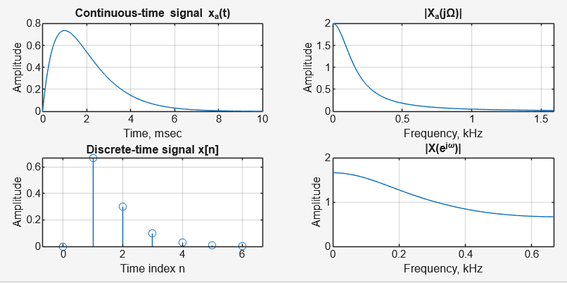  When the sampling period is increased to T=1.5 seconds, the sampling frequency decreases (fs​≈0.67 Hz). This lowers the Nyquist limit. Because the sampling rate is lower, the "spectral copies" in the frequency domain move closer together and overlap more significantly. This results in visible aliasing. You would observe that the discrete-time spectrum ∣X(ejω)∣ becomes more distorted compared to the original continuous spectrum ∣Xa​(jΩ)∣, particularly at higher frequencies within the plot, as the "folded" energy adds to the main spectrum.
Q9.12 Modify Program P9_3 for the case of $xa(t) = e^{-πt2}$ and repeat Questions Q9.10 and Q9.11. | 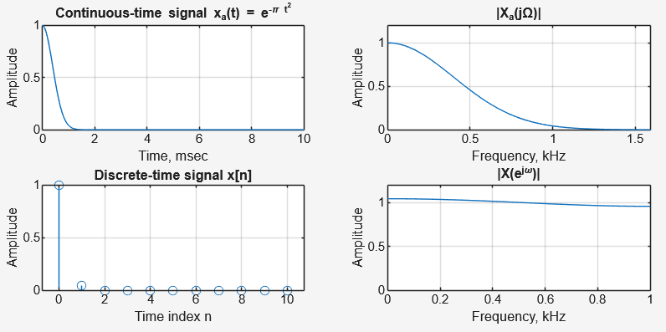  For the function xa​(t)=e^−πt2, the Fourier transform is analytically known to be Xa​(f)=e^−πf^2. Since this function decays very rapidly in both time and frequency domains, aliasing is often less severe than for the previous function, but it depends heavily on T. The code below modifies the signal generation and, crucially, replaces the freqs command (which is for rational transfer functions) with the direct calculation of the Gaussian Fourier transform to plot the correct theoretical spectrum.
Q9.13 What is the function of the operator == in Programs P9 5? | The operator == in MATLAB (and Program P9_5) is the relational equality operator. It is used to compare two values to determine if they are equal.  - It returns a logical 1 (true) if the values are equal.  - It returns a logical 0 (false) if they are not.  - In the context of the code if sign(bin(1)) == 0, it checks if the sign bit is 0 (positive) to decide the logic flow.
Q9.14 Using Program P9 4 develop the binary equivalents in sign-magnitude form of the following decimal fractions: (a) 0.80165, (b) − 0.80165, (c) 0.64333, and (d) − 0.9125 for the following values of the wordlengths: 6 and 8. Verify the results by hand calculation. | Using the logic of Program P9_4, the decimal fractions were converted to binary. The first bit represents the sign (0 for positive, 1 for negative), followed by the fractional bits determined by the wordlength  Decimal Number Wordlength (b) Binary Equivalent (Sign + Magnitude)  (a) 0.80165 b=6 0 110011  b=8 0 11001101  (b) -0.80165 b=6 1 110011  b=8 1 11001101  (c) 0.64333 b=6 0 101001  b=8 0 10100100  (d) -0.9125 b=6 1 111010  b=8 1 11101000  Sign: Number is positive, so Sign Bit = 0.  Magnitude: Multiply the fractional part by 2 repeatedly:  - Integer 1, Remainder  - Integer 1, Remainder  - Integer 0, Remainder  - Integer 0, Remainder  - Integer 1, Remainder  - Integer 1, Remainder  Result: Combining sign and integers gives 0 110011, matching the program output.
Q9.15 Using Program P9_5 determine the decimal equivalents of the binary fractions developed in Question Q9.19. How close are your answers to the original decimal fractions? | Original Decimal Wordlength used Reconstructed Decimal Difference (Error)  0.80165 $b=6$ 0.796875 0.004775  $b=8$ 0.800781 0.000869  -0.80165 $b=6$ -0.796875 0.004775  $b=8$ -0.800781 0.000869  0.64333 $b=6$ 0.640625 0.002705  $b=8$ 0.640625 0.002705  -0.9125 $b=6$ -0.906250 0.006250  $b=8$ -0.910156 0.002344  The reconstructed answers are close but not identical to the original fractions due to quantization error.  - With a wordlength of 6 bits, the maximum error is approximately (specifically half the least significant bit step size).  - With a wordlength of 8 bits, the precision improves significantly, reducing the error (e.g., for 0.80165, error drops from ~0.0048 to ~0.0009).  - For 0.64333, the 8-bit representation did not add a new '1' bit compared to the 6-bit version (the next bits were 0), so the value remained the same.
Q9.16 What is the purpose of the operator ~ in Program P9_6? | In Program P9_6, the operator ~ acts as the Logical NOT (or bitwise complement) operator. Its function is to invert the value of the bits in the binary array.  It changes every 0 to a 1.  It changes every 1 to a 0.  In the specific context of the code onescomp = ~bin, it is used to flip the bits of the magnitude part of the number to generate the One's Complement form for negative numbers.
Q9.17 Using Program P9_6 determine and verify the ones’-complement representations of the binary numbers developed in Question Q9.19. | Using the logic of Program P9_6 (which keeps positive numbers the same and inverts the magnitude bits for negative numbers), here are the One's Complement equivalents for the numbers from Q9.14.  Decimal Wordlength Original (Sign-Magnitude) One's Complement (Result)  0.80165 6 bits 0 110011 0 110011 (Unchanged)  -0.80165 6 bits 1 110011 1 001100 (Inverted Magnitude)  0.64333 6 bits 0 101001 0 101001 (Unchanged)  -0.9125 6 bits 1 111010 1 000101 (Inverted Magnitude)
Q9.18 What are the purposes of the operators | and & in Program P9 8? | In Program P9_7 (referred to as P9_8 in the question text), these operators are used to implement binary addition logic (specifically adding 1 to the LSB):  “&” (Bitwise AND): This operator is used in the condition if b(k) & c == 1. It checks if both the current bit b(k) and the carry c are 1. If both are 1, a binary overflow for that position occurs (1+1=10₂​), meaning the result bit becomes 0 and the carry propagates to the next bit.  “|” (Bitwise OR): This operator is used in the line twoscomp(k) = b(k) | c. It determines the value of the current bit when a "1+1" collision does not occur. It effectively sums the bit and the carry (e.g., 1+0=1).
Q9.19 Using Program P9_7 determine and verify the two’s-complement representations of the binary numbers developed in Question Q9.19. | Decimal One's Complement (Input) Calculation (Add 1 to LSB) Two's Complement (Result)  -0.80165 1 001100 LSB 0 + 1 = 1 (No Carry) 1 001101  -0.9125 1 000101 LSB 1 + 1 = 10₂ (Bit 0, Carry 1) Next 0 + 1 = 1$ (No Carry) 1 000110

- Conclusion
In this activity, we successfully explored the fundamental principles of processing continuous-time signals using digital tools. We utilized MATLAB to simulate the sampling process, demonstrating that a continuous-time signal can be represented by a discrete sequence through periodic sampling. A critical insight gained was the practical demonstration of aliasing in both the time and frequency domains; we observed that distinct frequencies (such as 3 Hz, 7 Hz, and 13 Hz) become indistinguishable in the discrete domain when the sampling rate is insufficient. This reinforced the necessity of the Nyquist sampling theorem, which requires a sampling rate greater than twice the signal's maximum frequency to prevent information loss and ensure accurate reconstruction. Additionally, we investigated the underlying data structures of Digital-to-Analog conversion by implementing binary encoding schemes, including sign-magnitude, one’s complement, and two’s complement forms. Overall, this activity highlighted the essential relationships between analog signals and their digital representations, emphasizing the limitations introduced by sampling rates and finite word lengths.

